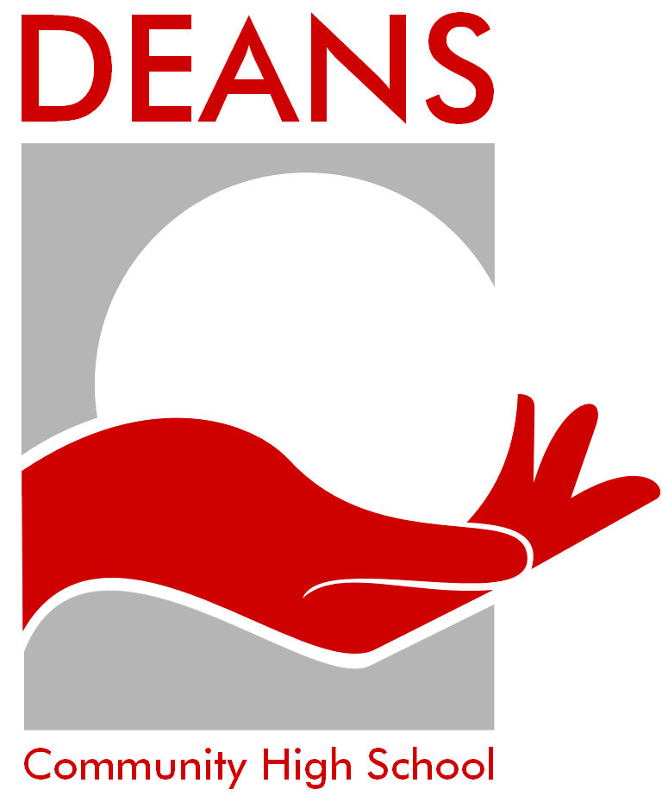
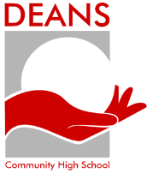
SUBJECT CHOICE FOR STUDY IN S5&S6
2026-27

www.deanscommunityhighschool.com

Please complete the electronic course choice form during your interview or by Friday 27th February 2026

Subjects
Level 5 Options  (National, National Progression Award, Skills for work) | Level 6 Options  (Higher, National Progression Award, Skills for work)
Applications of Maths | Accounting
West Lothian College Course (apply via the College website) | Administration
Games Development/Digital Media | Art
English | Biology /Human Biology (Please indicate your preference to study, however, please ensure you are willing to do either option)
Health Sector | Business Management
Retailing and Customer Services | Chemistry
Travel and Tourism | Computing Science
Early, Learning and Childcare | Drama
 | English
 | Early, Learning and Childcare
 | French
 | Furniture Making
 | Graphic Communication
 | Geography
 | History
 | Maths
 | Modern Studies
 | Music
 | NPA Play in a Sports Environment
 | PE
 | Physics
 | RMPS
 | Spanish
Please note: Courses will only run if numbers and resources are sufficient.

For a Level 5 Option which is not on the list above this can be studied in a S4 Class.

Options offered in S4

Administration and IT | Art and Design | Biology
Business | Chemistry | Childcare
Computing Science | Drama | French
Geography | Graphic Communication | History
Modern Studies | Music with performing | Physics
Physical Education | Religious, Moral and Philosophical Studies | Spanish
Woodwork

For S6 Only
S6 Options including Level 7 – Advanced Higher and Virtual Campus
Advanced Higher Subjects may be offered in school, or through the virtual campus. Please indicate your choice in one of the subject boxes in the electronic form.

The table below shows which subjects are available within the virtual campus.

Please note: Courses will only run if numbers and resources are sufficient.

Subject | Level | Subject | Level
Biology | Advanced Higher | Philosophy | Higher
Business | Advanced Higher
Chemistry | Advanced Higher
Computing | Advanced Higher
Geography | Advanced Higher
History | Advanced Higher
Maths | Advanced Higher
PE | Advanced Higher
Physics | Advanced Higher
RMPS | Advanced Higher

There is an opportunity to study via the Open University – Young Applicants in Schools Scheme (YAAS). Please refer to the link below and speak to Mrs Fleming if this is something you would like to consider.
https://www.open.ac.uk/scotland/study/courses-schools-and-early-learning/young-applicants-schools-scheme

LEAPS Transitions Course Level 7 www.leapsonline.org/transitions-course
Course Overview
The LEAPS Transitions Course is designed to give students the skills and experience they need to make a positive transition from school to university. Throughout the course, students work with academics and students from other schools on first-year university-level academic skills, developing confidence and an understanding of what it takes to be successful at university. This is a unique opportunity to get the ‘uni’ experience before starting for real.
Course Description
The course will be taught via interactive lectures, workshops, tutorial discussion, online participation and independent study. Students will also participate in project work, library research and meetings with tutors and students. Semester one will focus on academic skills and a writing assessment; semester two will have a lecture series and a group poster assessment.
Entry Requirements The course is offered to LEAPS - eligible UCAS applicants speak to Miss Thomson to see if you are LEAPS eligible.
We have no formal entry requirements, other than we anticipate students taking the course will be planning to apply to higher education. For example, students will either have Highers/Nat 5s required for university entry, or are taking these in S6.
Please speak to Miss Thomson for further information.

