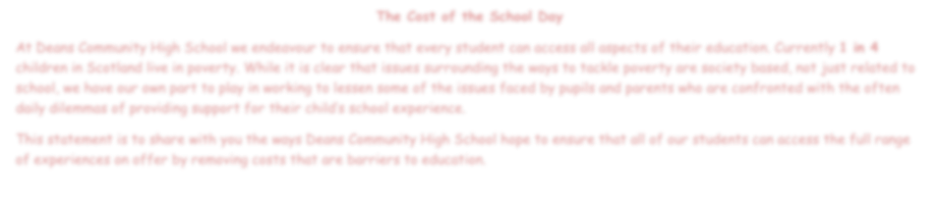

**The Cost of th**

**e School Day**

At Deans Community High School we endeavour to ensure that every student can access all aspects of their education. Currently

**in**

**4**

**1**

children in Scotland live in poverty. While it is clear that issues surrounding the ways to tackle poverty ar

e society based, not just related to

school, we have our own part to play in working to lessen some of the issues faced by pupils and parents who are confronted w

ith the often

daily dilemmas of providing support for their child’s school experience.

This st

atement is to share with you the ways Deans Community High School hope to ensure that all of our students can access the full

range

of experiences on offer by removing costs that are barriers to education.



Uniform

•

Our uniform policy helps our pupils feel more

included and allows our students to be a

recognisable part of their community.

•

We will ensure that pupils are aware that they can

wear ‘unbranded’ uniform.

•

We will operate a ‘tie swap’, replacing

donated

junior ties with senior ties for free

•

We will also encourage our S6 pupils, to donate

their ties and blazers in the hope that this will

become a tradition.

•

Our Pupil Support department have access to

uniform to support families.



Home Learning

Where necessary materials

includ

ing IT equipment is

available for pupils to support

home learning.



Learning

While we encourage pupils to

be self

-

sufficient and prepared

for lessons, we will provide any

materials required to

participate in any subject for

example stationary

equipment

and calculators.



School Clubs

A wide range of activities and learning opportunities

offered both at lunch and after school at no cost.



Trips

We recognise that trips are an integral part of the school curriculum and can

have a significant impact on pupils and therefore we want to guarantee that all

pupils are able to access them. Our staff are committed to ensuring that all trips

have educationa

l value and we, as a school, will endeavour to make them

available to all pupils.

•

We have a variety of ways to help with the costs associated with trips,

such as by spreading smaller payments over a longer period or by

paying for part, or all, of it.

•

End

of term activity days include numerous free activities for all

students.

•

A school raffle has been introduced to raise funds to subsidise school

activity days.

•

If you have any concerns regarding any trip payment to contact pupil

support.



Events

•

Fundra

ising events in our school, such as non

-

uniform days, require a donation only if possible.

We limit the number of these events and spread

them throughout the year.

•

Other events, such as school shows, will have

prices kept to an absolute minimum, and, simi

larly

to our trips policy, will still be available to pupils to

whom cost might be an issue.

•

While the cost of the S6 prom remains

unavoidably high, we have introduced the Pop

-

up

Prom shop, providing high

-

quality and fashionable

clothing to borrow for any

of our S6 pupils and S6

students are working together to fund raise in a

way that does not require input from students in

other year groups.



Meals

•

Breakfast Club is available

please speak to a member of

pupil support for details.

•

Free School

Meal

–

Pupils are

encouraged to use their

allowance at breakfast, break

or lunch.

